**Initial Utility Tree**

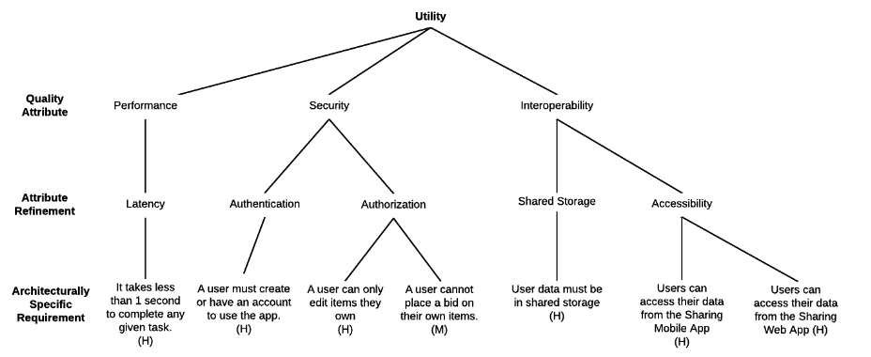

**Evaluations:**

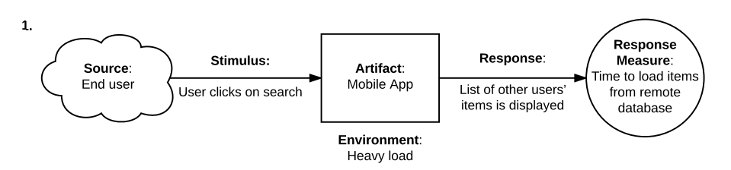

1. **Risk**. The system may not complete a task in less than one second based on the ASR. The time of response varied from 2 to 6 seconds during the testing phase.

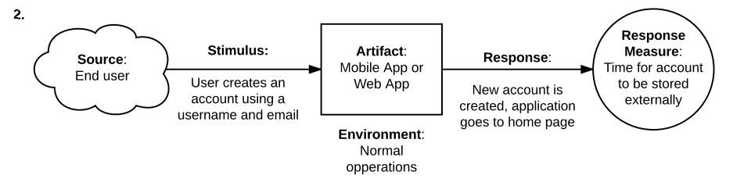

1. **Risk**. The system has a security risk for this one. Lacks password in the creation of account thus increasing possible vulnerabilities.

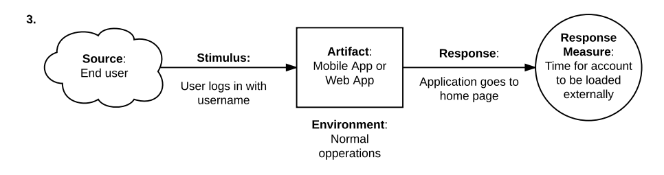

1. **Trade-off**. This is a trade-off between performance and security. Logging in with only the username makes loading relatively fast compared to logging in with email, but that already compromised the security. Logging in using email is more secured than with username only, but loading time is greater.

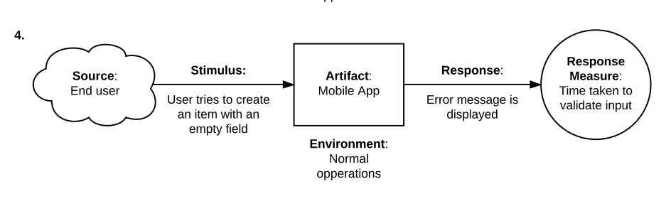

1. **Non-risk**. This is a non-risk scenario since form validations are great helpers and required for form inputs. The system responded with a helpful error message as expected after the form validation. The time taken to validate the input is also negligible.

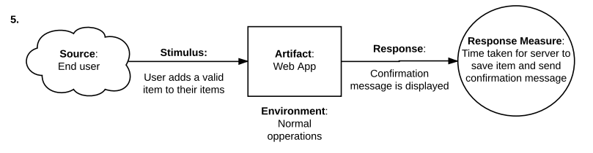

1. **Non-risk**. This is a non-risk scenario since the user is informed that their request is successfully handled. The time taken to save the item also complies with our ASR.

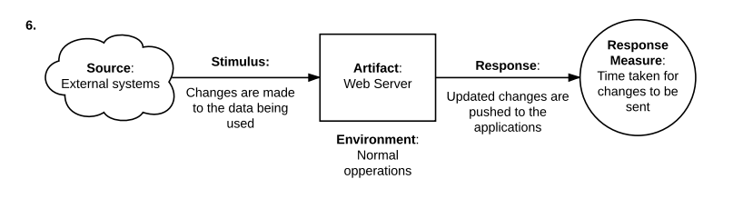

1. **Sensitivity Point**. Local data of the user may be unsynchronized with the remote data. Pull on the data first before allowing the user push their changes to the application.

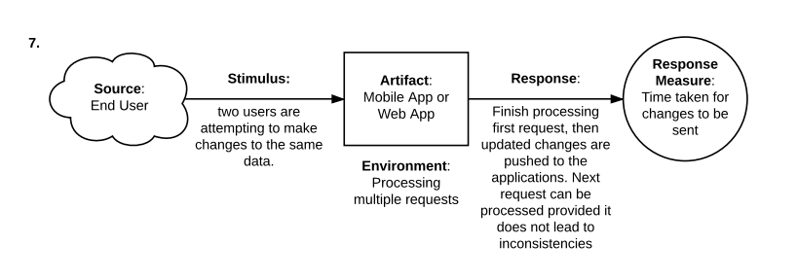

1. **Non-risk**. This is a non-risk since the concurrent requests of the users are handled properly. Locking of resources and executing a single operation one at a time will help in preserving data integrity and preventing clashing of the changes of the concurrent requests.